Bouldering
  - Why I like to climb but hate to fall


Contents
Introduction 2
Grades 2
Equipment 2
Shoes 2
Chalk 3
Competitions 3
Safety 4
Injuries 4
Get Started 4

Introduction
Bouldering is climbing at hights that don’t require a rope. Crash mats are used to protect climbers from falls. It involves problem solving, technique and building finger and grip strength. There is both indoor and outdoor climbing.

I climb at least once a week and have made reasonable progress over the last year. The community is really friendly and people are always encouraging and willing to offer tips.

Grades
In climbing there are different challenge levels to different climbs, and climbs are given grades so climbers know what challenge to expect.
…
 | Circle | Half-circle | Triangle | Square | Pentagon
Description | Easy, simple climbs | Beginner, may need to think about 1 or 2 moves | More challenging beta, smaller holds. | More challenging, technical climbs, requires some technique | For more experienced climbers
Experience (normal) | Beginner | Beginner – 2 weeks | 2 weeks – 3 months | 3 months – 1 year | 1 year +

Equipment
The first time you climb you will probably just rent some shoes and a chalk bag, but once you decide you want to do it regularly you’ll want to buy your own.

Shoes
Proper climbing shoes allow your feet to grip the holds. Your whole weight can be supported by tiny fingertip size holds with a good shoe with the correct fit.
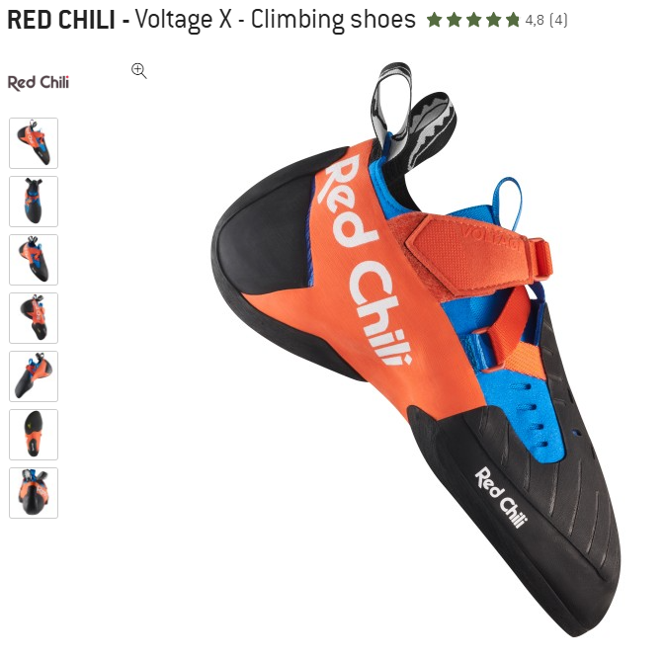

Figure 1 pro climbing show
Figure 2 beginner climbing shoe

Chalk
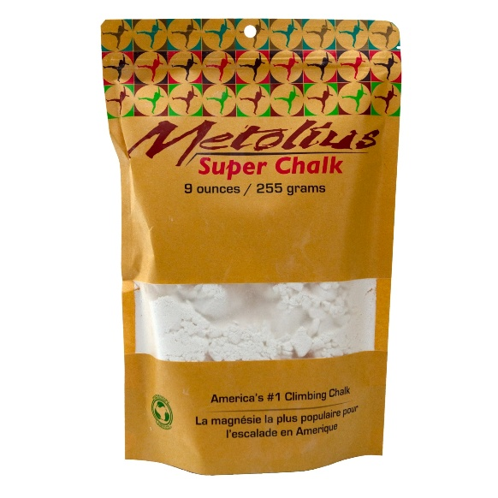
Essential for improving grip and protecting the skin on your fingers.

Competitions
There are many competitions, starting with local amateur competitions to the Olympic games.
Competitions are a good way of testing your skills and pushing yourself to try some routes you might not normally try.

Safety
It’s crucial to observe the rules when climbing, both for your own and for other’s safetly.
- Avoid walking under someone’s fall zone when on the mats.
- Never ‘spot’ someone by attempting to catch them if they fall. That’s what the mats are for.
- When starting a route, check the route is clear, before you begin.
- Don’t bring drinks or food onto the mats. They are a fall injury risk and lead to the holds becoming dirty.

Injuries
Reduce your chances of getting an injury by:
- Always warming up with stretches, hangs and finger and grip exercises
- Start on easier routes
- Rest between practice sessions
If you do get an injury, make sure you give it time to heal before climbing again. Training on an injury will mean delaying your healing time and possibly making it a lot worse.

Get Started
If you’re ready to get started, find your local climbing gym and sign up for an induction.
Here is a directory to help you find yours.
UKC Directory
If you can climb more than once a week that will help you improve a lot, but even once a week is enough to get a lot of enjoyment out of it, even if progress is slower.
It’s a great social activity, so why not bring a friend. In any case, expect to make a few while you’re there.

